https://www.simplilearn.com/tutorials/devops-tutorial/devops-interview-questions

1. How is DevOps different from agile methodology?

[DevOps](https://www.simplilearn.com/tutorials/devops-tutorial/what-is-devops) is a culture that allows the development and the operations team to work together. This results in continuous development, testing, integration, deployment, and monitoring of the software throughout the lifecycle.

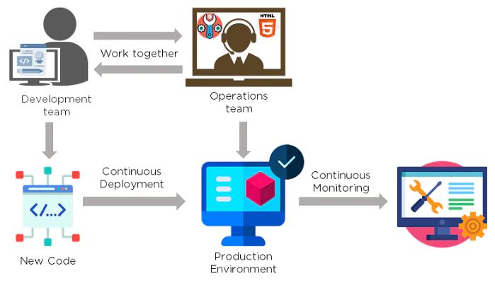

A[gile](https://www.simplilearn.com/tutorials/agile-scrum-tutorial/what-is-agile) is a software development methodology that focuses on iterative, incremental, small, and rapid releases of software, along with customer feedback. It addresses gaps and conflicts between the customer and developers.

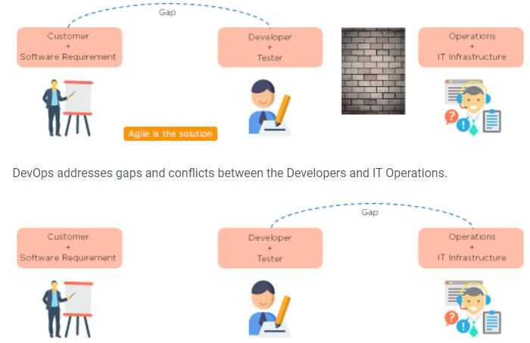

### Which are some of the most popular DevOps tools?

The most popular [DevOps tools](https://www.simplilearn.com/tutorials/devops-tutorial/devops-tools) include:

1. Selenium
2. Puppet
3. Chef
4. Git
5. Jenkins
6. Ansible
7. Docker

### What are the different phases in DevOps?

The various phases of the DevOps lifecycle are as follows:

* Plan - Initially, there should be a plan for the type of application that needs to be developed. Getting a rough picture of the development process is always a good idea.
* Code - The application is coded as per the end-user requirements.
* Build - Build the application by integrating various codes formed in the previous steps.
* Test - This is the most crucial step of the application development. Test the application and rebuild, if necessary.
* Integrate - Multiple codes from different programmers are integrated into one.
* Deploy - Code is deployed into a cloud environment for further usage. It is ensured that any new changes do not affect the functioning of a high traffic website.
* Operate - Operations are performed on the code if required.
* Monitor - Application performance is monitored. Changes are made to meet the end-user requirements.

### 

### 5. Mention some of the core benefits of DevOps.

The core benefits of DevOps are as follows:

#### **Technical benefits**

* Continuous software delivery
* Less complex problems to manage
* Early detection and faster correction of defects

#### **Business benefits**

* Faster delivery of features
* Stable operating environments
* Improved communication and collaboration between the teams

### 6. How will you approach a project that needs to implement DevOps?

The following standard approaches can be used to implement DevOps in a specific project:

Stage 1

An assessment of the existing process and implementation for about two to three weeks to identify areas of improvement so that the team can create a road map for the implementation.

Stage 2

Create a proof of concept (PoC). Once it is accepted and approved, the team can start on the actual implementation and roll-out of the project plan.

Stage 3

The project is now ready for implementing DevOps by using version control/integration/testing/deployment/delivery and monitoring followed step by step.

By following the proper steps for [version control](https://www.simplilearn.com/tutorials/devops-tutorial/version-control), integration, testing, deployment, delivery, and monitoring, the project is now ready for DevOps implementation.

### What is the difference between [continuous delivery and continuous deployment?](https://www.simplilearn.com/tutorials/devops-tutorial/continuous-delivery-and-continuous-deployment)

|  |  |
| --- | --- |
| Continuous Delivery | Continuous Deployment |
| Ensures code can be safely deployed on to production | Every change that passes the automated tests is deployed to production automatically |
| Ensures business applications and services function as expected | Makes software development and the release process faster and more robust |
| Delivers every change to a production-like environment through rigorous automated testing | There is no explicit approval from a developer and requires a developed culture of monitoring |

### 

### What is the role of configuration management in DevOps?

* Enables management of and changes to multiple systems.
* Standardizes resource configurations, which in turn, manage IT infrastructure.
* It helps with the administration and management of multiple servers and maintains the integrity of the entire infrastructure.

### 9. How does continuous monitoring help you maintain the entire architecture of the system?

Continuous monitoring in DevOps is a process of detecting, identifying, and reporting any faults or threa ts in the entire infrastructure of the system.

* Ensures that all services, applications, and resources are running on the servers properly.
* Monitors the status of servers and determines if applications are working correctly or not.
* Enables continuous audit, transaction inspection, and controlled monitoring.

10. What is the role of AWS in DevOps?

AWS has the following role in DevOps:

* Flexible services - Provides ready-to-use, flexible services without the need to install or set up the software.
* Built for scale - You can manage a single instance or scale to thousands using AWS services.
* Automation - AWS lets you automate tasks and processes, giving you more time to innovate
* Secure - Using AWS Identity and Access Management (IAM), you can set user permissions and policies.
* Large partner ecosystem - AWS supports a large ecosystem of partners that integrate with and extend AWS services..

### 11. Name three important DevOps KPIs.

The three important KPIs are as follows:

* Meantime to failure recovery - This is the average time taken to recover from a failure.
* Deployment frequency - The frequency in which the deployment occurs.
* Percentage of failed deployments - The number of times the deployment fails.

### 12. Explain the term "Infrastructure as Code" (IaC) as it relates to configuration management.

* Writing code to manage configuration, deployment, and automatic provisioning.
* Managing data centers with machine-readable definition files, rather than physical hardware configuration.
* Ensuring all your servers and other infrastructure components are provisioned consistently and effortlessly.
* Administering cloud computing environments, also known as infrastructure as a service (IaaS).

### 13. How is IaC implemented using AWS?

Start by talking about the age-old mechanisms of writing commands onto script files and testing them in a separate environment before deployment and how this approach is being replaced by IaC. Similar to the codes written for other services, with the help of AWS, IaC allows developers to write, test, and maintain infrastructure entities in a descriptive manner, using formats such as JSON or YAML. This enables easier development and faster deployment of infrastructure changes.